

G2 EE

PUS creation tool

QAD EE Training Document
PUS creation tool

Table of Contents
Transportation Order Management 3
*PUS Order Creation/*Full Truck Load 12.10 3
*Export PUS (csv) 12.11 7

Transportation Order Management

*PUS Order Creation/*Full Truck Load 12.10
This program can be used together with 12.11 to create an upload file for INET to order the transport for LTL and Groupage shipments.
For this program to function packaging data must be set up correctly for all items in 13.14.4 and 13.14.7. See the Packaging Setup instruction for details.
Certain setups are also necessary in generalized codes for the creation of IDs and the set up of means of transport. Should you receive error messages relating to this contact IT.
This program works best in Terminal mode. Change this be right clicking on the program and selecting properties.
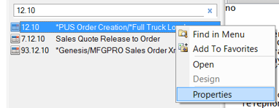
Under Program change from Desktop to Terminal.
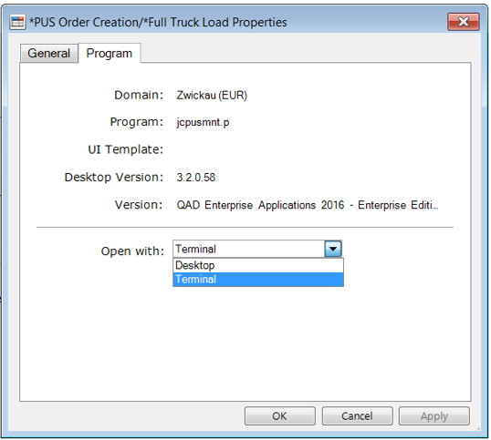
You can the open the program as usual. This setting will be saved and (unless you change it back) the program will automatically open in Terminal mode.

To create an INET load file start by entering the Site and Supplier number.
Leave the Id field empty and click Next to create an ID automatically.

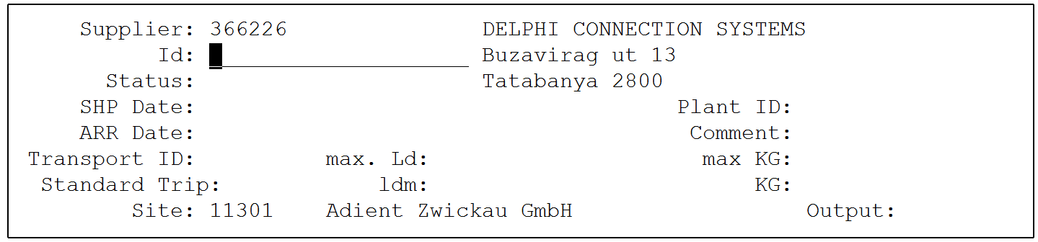
To create an Id number press Enter / F1. You will be asked if you are adding a new record, say you will be asked if you are adding a new record, say Yes.
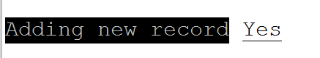
An Id number will then be created.
Enter the collection and delivery dates and times that should be included in the INET file. You must also mention the means of transport.
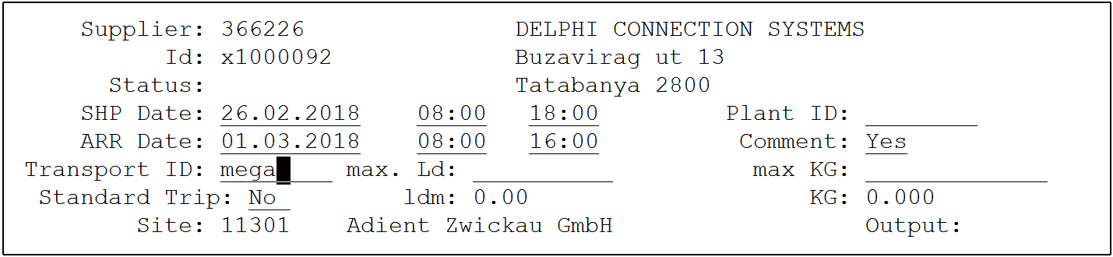

Press enter / F1. If comments is left as yes a Remarks window will open where remarks can be entered.
Next you will need to select the type of data you want to see.
Transport for an ASN already in the system: ASN/REC
Manual qty entry: MAN
Quantities and dates based on the schedule: SCHD
Import file – not currently used: IMP
Typically you will use SCHD.
Choose between discr and net, typically you will want to order for the net quantities.

The system will then show you the dates for which scheduled orders are available in the system. Use the arrow keys ↑↓ to scroll up and down
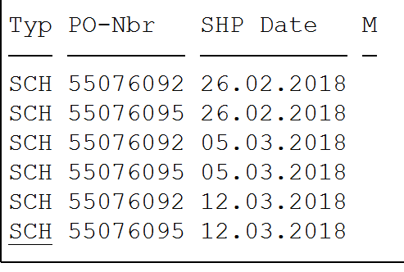
Press enter and enter again to select the shipment. You will see the quantities on the right of the screen and an X will appear next to the selected date. You can select more than one (above, for example, there are 2 POs for one supplier, so the qtys for both POs can be selected).
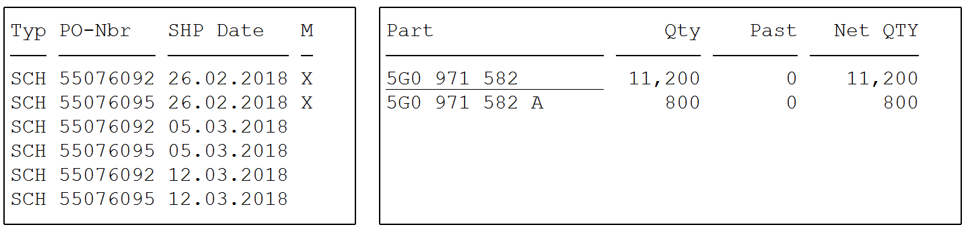
If you select a date by mistake reenter using enter and then exit using F4. The X will disappear.
Once all dates have been selected press F4. You will be asked to confirm the shipment dates and times.
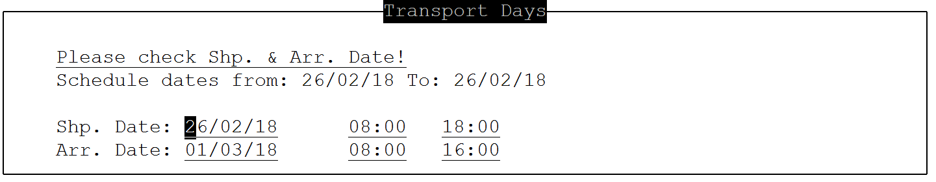
Change if required and exit using F4.
You will return to this screen
Press F4 again.

Now you will be shown all quantities to be shipped
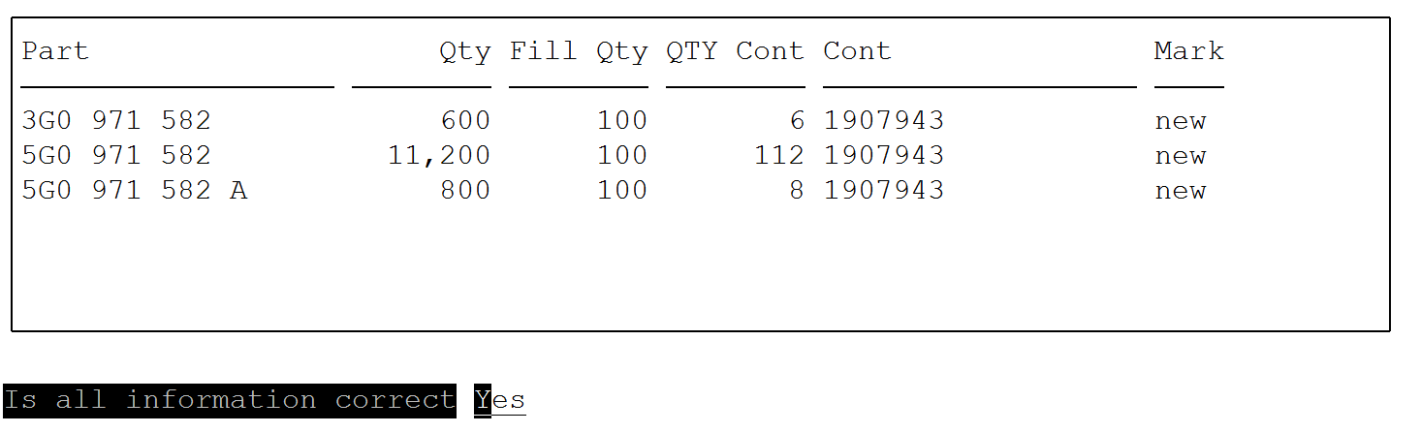
Confirm if information is correct. You will enter the list of parts. If you need to change the data press enter and you will access the part data at the bottom of the screen. 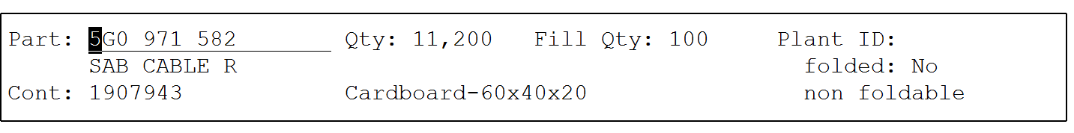
Change as required and confirm.
Press F4.
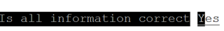
Press enter to confirm information is correct.
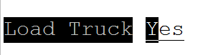
Press enter to load truck.

Proceed to the next point Export PUS (csv) 12.11 to complete the process.

*Export PUS (csv) 12.11
To export the PUS created in 12.10 (see above) enter the relevant data in the required fields:
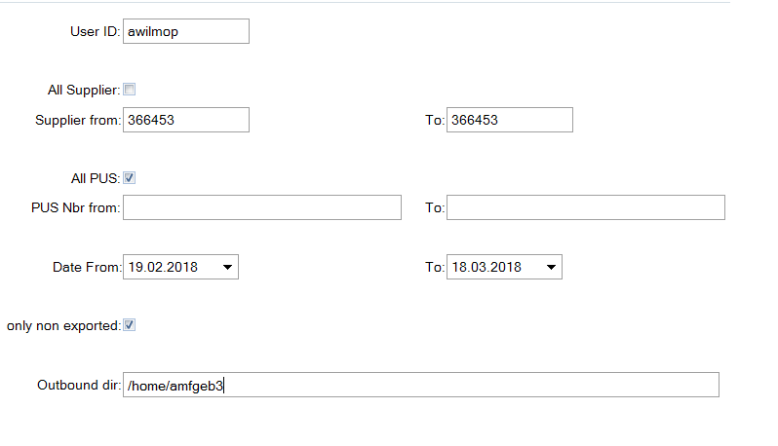
Outbound dir: The outbound directory for your facility should automatically be displayed here. If not talk to your IT team/help desk.
Once exported you can find the file in that directory and transfer it onto your PC using WINSCP or similar.
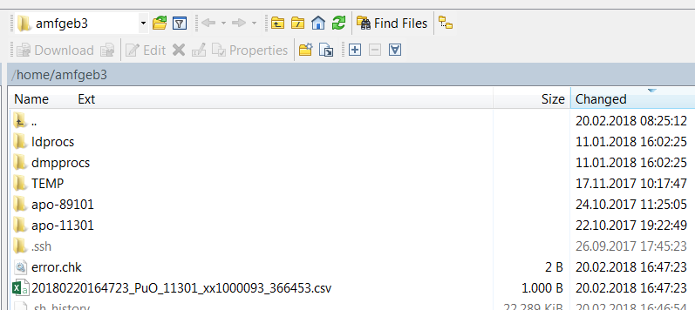
The file will contain the data from the shipment you entered.
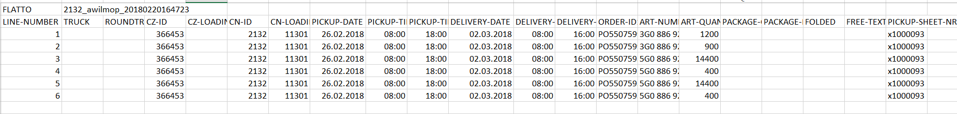

Upload into INET according to your standard process.

